Community Centre 55 - 2024 Share a Christmas Program
Referral and Consent Form - Please Print Clearly (will not accept if not legible)
Deadline to submit applications is Friday, November 29, 2024 (4PM)

First Name__________________ Last Name__________________ Date of Birth _______/_________/________
*(Must match ID)* Day Month Year

Name of Agency (if applicable) _________________________________________________________________
**Please note that the deadline for agency submissions is one week earlier than the general deadline.

Address _________________________________________________Apt_____________Entry Code _______________

Telephone (_____) ____________________ Alternate # (_____) ___________________ Postal Code ______________

E-Mail Address ____________________________________________________________________________________

Adults (17 & Over) Permanently Residing in this Household
First Name Last Name (Must match ID) | Relationship to  Applicant | Date of Birth  Day Month Year | Gender

Children (16 and Under) Permanently Residing in this Household
First Name Last Name | Relationship to  Applicant | Age | Gender

I, the Recipient noted above, hereby consent to the disclosure of the above information to Community Centre 55, its staff and volunteers for the “Share-A-Christmas” Programme. Personal information is collected for Community Centre 55 under the authority of the Freedom of Information and Protection of Privacy Act, R.S.O. 1990, chapter F-31, the Municipal Freedom of Information and Protection of Privacy Act, R.S.O. 1990, chapter M-56, the Municipal Act, R.S.O. 1980, c.302 (as amended), and relevant By-law(s), and will be used to administer the Share-A-Christmas Programme, and will also be used to distribute information to you regarding Community Centre 55’s other programmes and events. I, the Recipient noted above, acknowledge that I am responsible for ensuring that the food provided by Community Centre 55 is properly cooked by me and agree to not use, and to properly dispose of, any food for which the 'Best Before' date has expired. I further agree to read and follow all instructions and warning labels on the toys and ensure they are safely used. Community Centre 55 is unable to replace any lost, stolen or misplaced food, toys or gift cards. I, the Recipient noted above, hereby release and indemnify Community Centre 55 from all claims, damages, and actions whatsoever with respect to the food, toys, or any other product or service provided by Community Centre 55, its staff and / or its volunteers for the Share-A-Christmas Campaign. I, the Recipient, acknowledge that I am signing this on behalf of myself and the others noted and warrant that I am the parent or guardian of the minor(s) noted herein. By providing my email address, I agree to receive information regarding Community Centre 55 programmes, events and services as well as information that Community Centre 55 feels that may be beneficial to its clients. Community Centre 55 may, in its sole discretion, determine what level of assistance (if any) is provided to individuals/families. Reasons for denying assistance include, but are not limited to, providing false information and applying for assistance through another agency.

I acknowledge that I have read, understood, and agree to all of the conditions set out above.

Signature ______________________________________________ Date _____________________________

To be Signed by a Community Agency or Professional

If you were registered for the 2023 Share a Christmas program, a signature for a referring agent is not required.

I was registered in Centre 55’s 2023 Share a Christmas program

If you were not registered for the 2023 Share a Christmas program, the following section must be completed.

I, the undersigned Referrer, acknowledge that I am referring a family for Community Centre 55’s Share-A-Christmas Program. I hereby acknowledge that: (a) I know the applicant; (b) the children and/or adults listed above reside with the applicant; (c) the residence where the Recipient lives is within the Share-A-Christmas boundaries (North of Lake Ontario to the south side of Danforth Ave., West Side of Victoria Park Ave. to the East Side of Coxwell Ave.); (d) in my opinion, the family is in need of Christmas Help. Thank You - Your referral may be verified.

Referrer’s Name: __________________________________________

Organization: __________________________________________

Address: __________________________________________

Postal Code: __________________________________________

Telephone: __________________________________________

Signature: __________________________________________

- Forms may be returned by:
  - In person drop off to Community Centre 55, 97 Main Street. Monday to Friday, 9:30am –4:00 pm until Friday, November 29, 2024.
- Clients must live within Community Centre 55’s catchment area to be eligible for Christmas assistance. Our boundaries are North of Lake Ontario to the south side of Danforth Ave., West Side of Victoria Park Ave. to the East Side of Coxwell Ave.
- The name written on the application must be printed neatly and must match your ID. If the names do not match, your application will not be processed.
- If you have any questions regarding the 2024 Share a Christmas program, contact Tamara Mehdinejad at 416-691-1113 x 223 or tamara@centre55.com.

This form must be completed for all families with children 16 years of age and under.
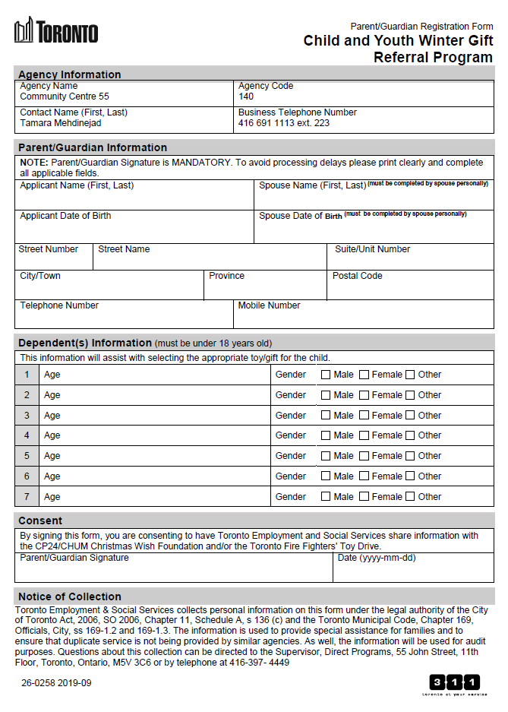

Community Centre 55
Share a Christmas Program 2024

Based on the feedback received following the 2021 Share a Christmas program, Community Centre 55 made the decision to provide clients with a grocery gift card in lieu of fresh and non-perishable foods. Toys will be provided for children 16 years of age and under.

When you drop off your form, you will be advised of your pick-up or delivery date.

Please fill out the attached forms with care as the information is used to prepare your Christmas assistance. We must to be able to read the names, ages, dates of birth, telephone numbers and most importantly the address. If possible, please include an email address as this is the primary means of communication and is used to provide you with information throughout the year.

Please Note: The purpose of Community Centre 55's Share A Christmas Program is to help to ease the burden or distress experienced by families and individuals who are in need during the Christmas Season. We help to strengthen families by supplementing their Christmas by transferring the gifts and donations received from the community to those in need. We attempt to maintain the quality of service each year; however the program is subject to the availability of donations.

If you have any questions regarding Community Centre 55’s Share-A-Christmas Program, please contact Tamara at (416) 691-1113 ext. 223.

